Experiment 2

Perform Operations on Vectors, Matrices and Arrays in R

PART B

PART B: TO BE COMPLETED BY STUDENTS)
(Students must submit the soft copy as per following segments within two hours of the practical. The soft copy must be uploaded on the ERP or emailed to the concerned lab in charge faculties at the end of the practical in case the there is no ERP access available)
Roll No. 60 | Name: Avdhut Parish Madhavi
Class : S.E. - C | Batch : C-2
Date of Experiment: | Date of Submission:-
Grade :

Observation: (Run the programs given above in R studio and paste screenshots of along with the output)
  - Vector Operations

Input :-
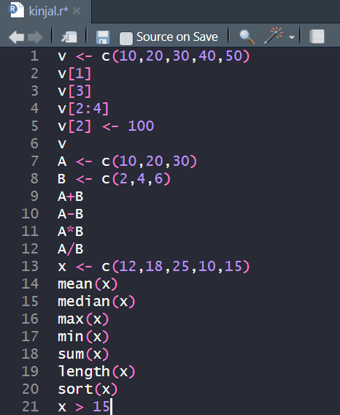
Output:-
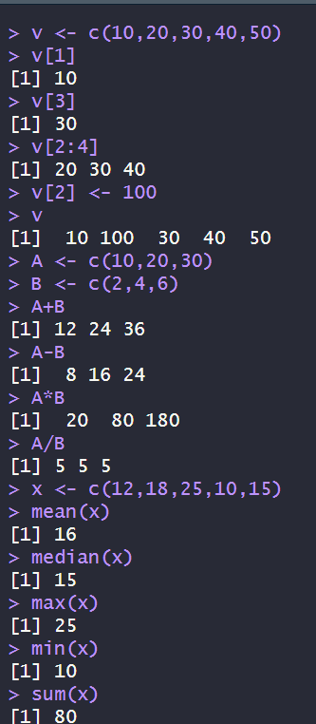
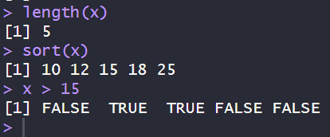
  - Matrix Operations

Input:-
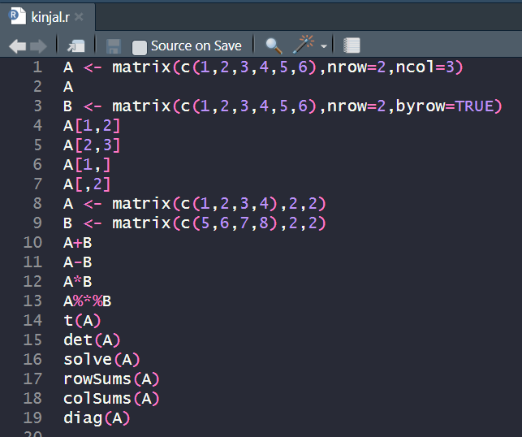
Output:-
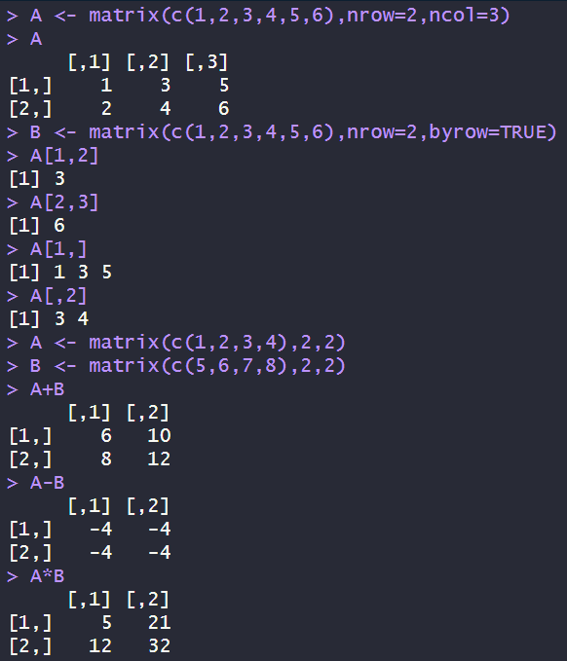
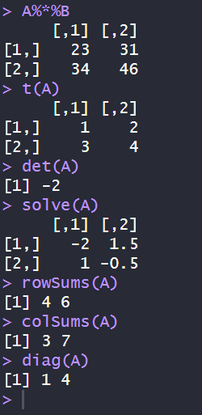
  - Array Operations

Input:-
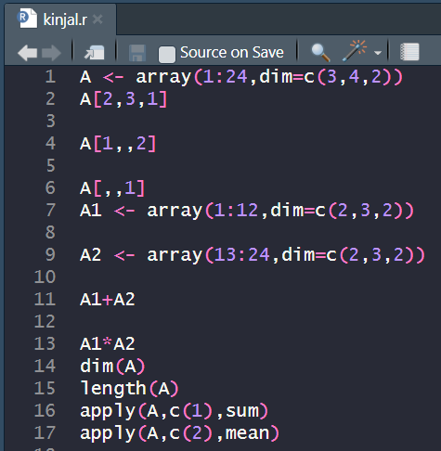
Output:-
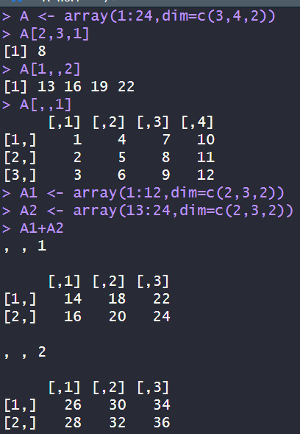
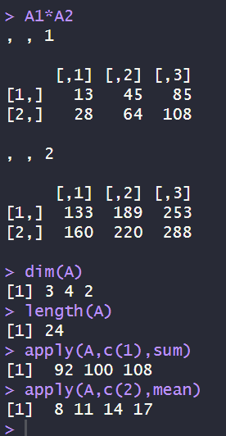

Observation Table:
Operation | Result
Vector Creation | Successfully created one-dimensional vectors
Vector Arithmetic | Addition, subtraction, multiplication, and division performed correctly
Statistical Functions | Mean, median, sum, maximum, and minimum computed successfully
Matrix Operations | Matrix addition, multiplication, transpose, determinant, and inverse executed correctly
Array Operations | Three-dimensional arrays created and manipulated successfully
Apply Function | Row-wise and column-wise computations performed successfully

Result
The experiment was successfully performed. Vectors, matrices, and arrays were created using R, and various arithmetic, statistical, and matrix operations were executed correctly. The experiment demonstrated efficient manipulation of one-dimensional, two-dimensional, and multidimensional data structures in R.

Applications
- Statistical data analysis
- Scientific computing
- Machine Learning preprocessing
- Image processing (multidimensional arrays)
- Financial data analysis
- Engineering computations
- Healthcare analytics
- Artificial Intelligence applications

Precautions
- All elements in a vector or matrix must be of the same data type.
- Ensure matrices have compatible dimensions before performing matrix multiplication.
- The inverse of a matrix exists only if its determinant is non-zero.
- Use proper indexing while accessing vector, matrix, or array elements.
- Verify dimensions before performing arithmetic operations on arrays.
- Save the R script before execution to avoid loss of work.

Questions of Curiosity
- What is a vector in R?
- How do you create a vector in R?
- What is the difference between a vector and a list?
- What are the different types of vectors?
- How is a matrix different from a vector?

Answers:-
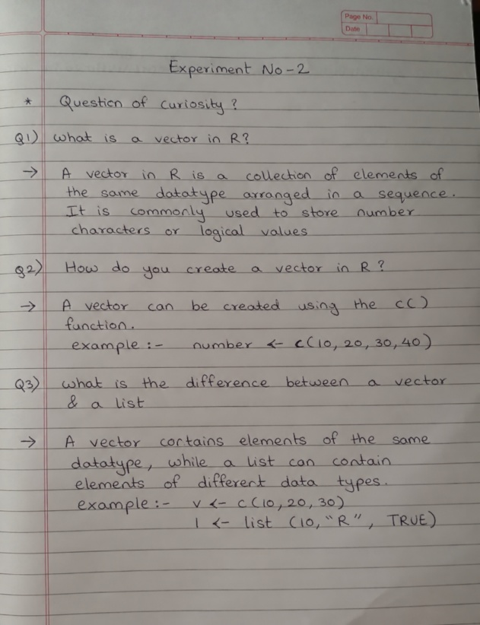
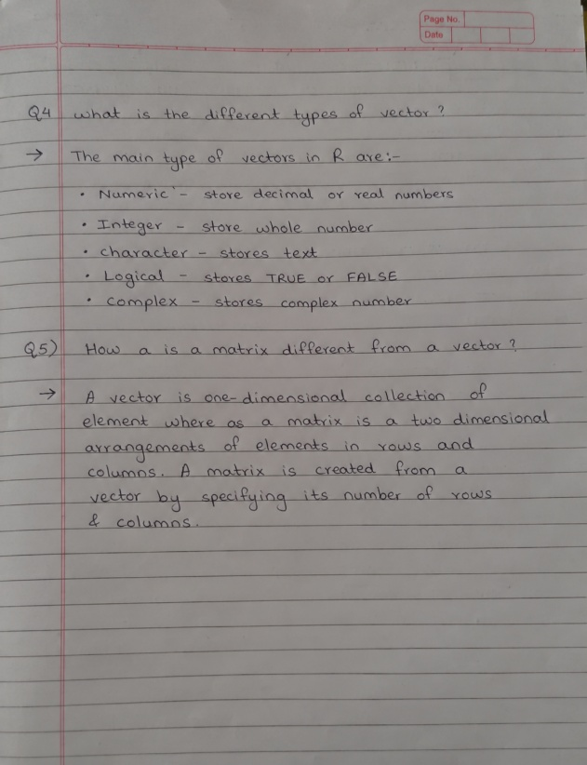

Viva Voce Questions
- What is a vector in R?
- How do you create a vector in R?
- What is the difference between a vector and a list?
- What are the different types of vectors?
- How is a matrix different from a vector?
- Explain the matrix() function.
- What is the purpose of %*% in R?
- Differentiate between * and %*%.
- What is the transpose of a matrix?
- What is the determinant of a matrix?
- When can the inverse of a matrix be calculated?
- What is an array in R?
- How is an array different from a matrix?
- Explain the apply() function.
- What is the purpose of dim() and length() functions?
- How do you access elements in a three-dimensional array?
- What statistical functions are commonly used with vectors?
- What happens if vectors of unequal lengths are added in R?
- What are the applications of matrices in data science?
- Why are vectors, matrices, and arrays important in R programming?

